Laboratory work №6

Theoretical background
Photo resistors, also known as light dependent resistors (LDR), are light sensitive devices most often used to indicate the presence or absence of light, or to measure the light intensity. In the dark, their resistance is very high, sometimes up to 1MΩ, but when the LDR sensor is exposed to light, the resistance drops dramatically, even down to a few ohms, depending on the light intensity. LDRs have a sensitivity that varies with the wavelength of the light applied and are nonlinear devices. They are used in many applications but are sometimes made obsolete by other devices such as photodiodes and phototransistors. Some countries have banned LDRs made of lead or cadmium over environmental safety concerns.
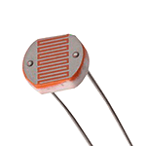

Light dependent resistor definition
Photo resistors are light sensitive resistors whose resistance decreases as the intensity of light they are exposed to increases.

Characteristics

Types of photo resistors and working mechanisms
Based on the materials used, photo resistors can be divided into two types; intrinsic and extrinsic. Intrinsic photo resistors use undoped materials such as silicon or germanium. Photons that fall on the device excite electrons from the valence band to the conduction band, and the result of this process are more free electrons in the material, which can carry current, and therefore less resistance. Extrinsic photo resistors are made of materials doped with impurities, also called dopants. The dopants create a new energy band above the existing valence band, populated by electrons. These electrons need less energy to make the transition to the conduction band thanks to the smaller energy gap. The result is a device sensitive to different wavelengths of light. Regardless, both types will exhibit a decrease in resistance when illuminated. The higher the light intensity, the larger the resistance drop is. Therefore, the resistance of LDRs is an inverse, nonlinear function of light intensity.

Wavelength dependency
The sensitivity of a photo resistor varies with the light wavelength. If the wavelength is outside a certain range, it will not affect the resistance of the device at all. It can be said that the LDR is not sensitive in that light wavelength range. Different materials have different unique spectral response curves of wavelength versus sensitivity. Extrinsic light dependent resistors are generally designed for longer wavelengths of light, with a tendency towards the infrared (IR). When working in the IR range, care must be taken to avoid heat buildup, which could affect measurements by changing the resistance of the device due to thermal effects. The figure shown here represents the spectral response of photoconductive detectors made of different materials, with the operating temperature expressed in K and written in the parentheses.
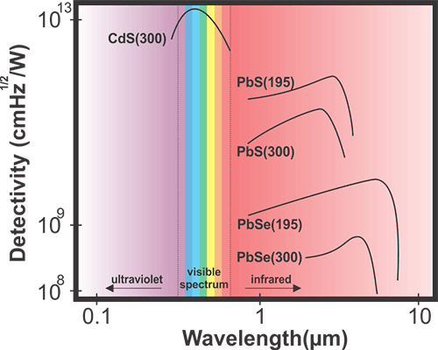

Sensitivity
Light dependent resistors have a lower sensitivity than photo diodes and photo transistors. Photo diodes and photo transistors are true semiconductor devices which use light to control the flow of electrons and holes across PN-junctions, while light dependent resistors are passive components, lacking a PN-junction. If the light intensity is kept constant, the resistance may still vary significantly due to temperature changes, so they are sensitive to temperature changes as well. This property makes LDRs unsuitable for precise light intensity measurements.

Latency
Another interesting property of photo resistors is that there is time latency between changes in illumination and changes in resistance. This phenomenon is called the resistance recovery rate. It takes usually about 10 ms for the resistance to drop completely when light is applied after total darkness, while it can take up to 1 second for the resistance to rise back to the starting value after the complete removal of light. For this reason the LDR cannot be used where rapid fluctuations of light are to be recorded or used to actuate control equipment, but this same property is exploited in some other devices, such as audio compressors, where the function of the light dependent resistor is to smooth the response.

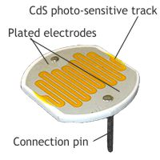Construction and properties of Photo resistors
Since the discovery of selenium photoconductivity, many materials have been found with similar characteristics. In the 1930s and 1940s PbS, PbSe and PbTe were studied following the development of photoconductors made of silicon and germanium. Modern light dependent resistors are made of lead sulfide, lead selenide, indium antimonide, and most commonly cadmium sulfide and cadmium selenide. The popular cadmium sulfide types are often indicated as CdS photoresistors. To manufacture a cadmium sulfide LDR, highly purified cadmium sulfide powder and inert binding materials are mixed. This mixture is then pressed and sintered. Electrodes are vacuum evaporated onto the surface of one side to form interleaving combs and connection leads are connected. The disc is then mounted in a glass envelope or encapsulated in transparent plastic to prevent surface contamination. The spectral response curve of cadmium sulfide matches that of the human eye. The peak sensitivity wavelength is about 560-600 nm which is in the visible part of the spectrum. It should be noted that devices containing lead or cadmium are not RoHS compliant and are banned for use in countries that adhere to RoHS laws.
Working process
- Assemble the circuit below;
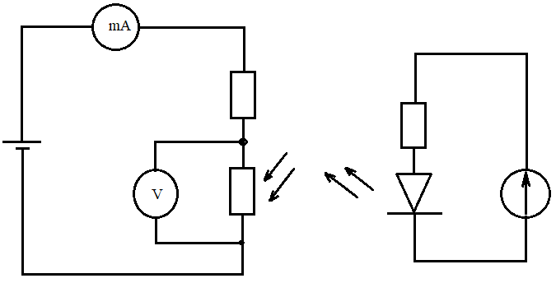
- Changing the light flux construct the IV characteristics depending on light flux;
- Using the luxmeter measure the light luminosity (E) and flux (Ф) in each measurement written in 2;
- Calculate sensitivity of LDR in each experiment using formula
$$S=\frac{I_{ph}}{Ф}$$
where I_{ph} = I – I_{sh,} I_{sh} – dark current. You can measure it covering LDR and obtaining results from ampermeter;
- Construct I-V curve;
- Construct sensitivity curve;

